7.50: First get speed at the top of the hill for the block to clear the pit.
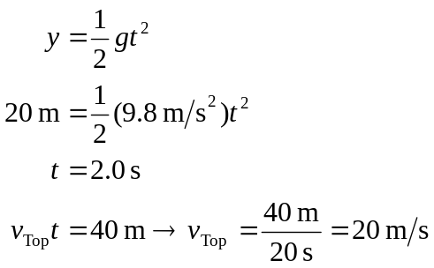
Energy conservation:
